Lab 7 Notes

Lab 7 Solution
In the solution for Lab 7, Lab07_Ans_Uic_2024.sql, the SQL commands were done in this order:
(1) Create tables, (2) Insert values into table, then (3) Alter table for foreign key.
This works when we copy the whole file and run it as a SQL.

In Lab 6 solution, we (1) Create tables, then (2) Alter table for foreign key.
If we then try to insert values, we get a circular referencing error for tables instructor and program.

Circular Referencing
Table instructor's p_code has program's p_code as foreign key
Table program's director_id has instructor's id as foreign key
This causes a circular reference problem when we try to insert values for instructor or program.

Creating Foreign Key
From Lab06_Ans_UIC def.txt, which is the solution to Lab 6, we created foreign keys in step (2).
ALTER TABLE instructor ADD FOREIGN KEY (p_code) REFERENCES program(p_code);
ALTER TABLE program ADD FOREIGN KEY (director_id) REFERENCES instructor(id);

Note: we could have added a constraint name, as in the bottom of Lab 7 solution.
ALTER TABLE `instructor`
ADD CONSTRAINT `instructor_ibfk_1` FOREIGN KEY (`p_code`) REFERENCES `program` (`p_code`);

Constraint name for foreign key
At LHS navigation panel, expand information_schema
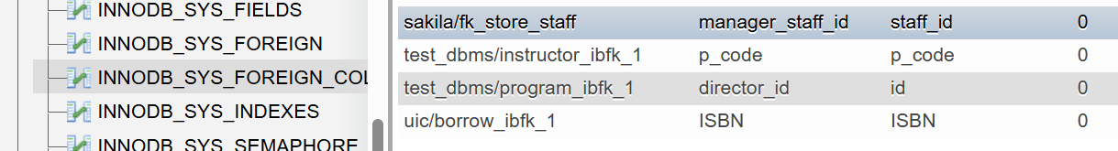

Solution next week
Drop the faulty DB tables. (Use drop table in the SQL tab or click the red drop button on the list of tables.)
Drop the relation tables first, then drop the entities table.
To drop instructor and program, must drop the foreign keys before dropping these tables.
Then reinstall Lab 7 solution by running it as a SQL.

Dropping Foreign Key
ALTER TABLE instructor
DROP CONSTRAINT instructor_ibfk_1

ALTER TABLE program
DROP CONSTRAINT program_ibfk_1

(Later you will learn CASCADE, a better way to do this.)

Follow this steps to fix the circular referencing problem:
Drop the foreign keys for instructor and program, as indicated in Dropping Foreign Key above,
Insert values for instructor and program, as indicated in step (1a) in Lab07b addendum,
Specify the foreign keys, step (2b) in Lab07b addendum or Creating Foreign Key above.

